6A^{th} Grade: Unit 14, Lesson 2

- Write an equation that can be represented by the bar model shown.
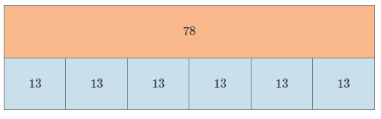

78=13×6 or equivalent

- Lorenzo had $1.70 in hit wallet and $1.88 in his jeans pocket. How much money did he have altogether?

$3.58

- What is the value of the expression 2.2 + 5.5?

7.7

- What fraction could be modeled by the diagram provided?
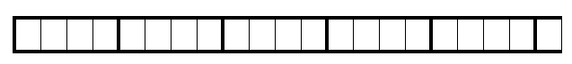

$$5\frac{1}{4}$$

- According to the bar model, what is the value of $\frac{3}{5}$ of $2\frac{1}{2}$?
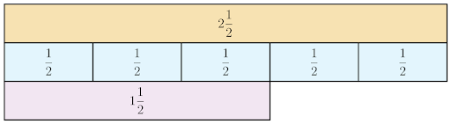

$$1\frac{1}{2}$$

- What is the common denominator of $4\frac{3}{8}$ and $\frac{2}{7}$?

56

